[](https://www.bhu.ac.in/Site/Home/_2_16)

DISSERTATION

ON

“EMOTION CLASSIFICATION ON EEG SIGNAL

THROUGH DEEP LEARNING”

Submitted by

Yogesh Pandey

Exam roll no- 21419MAC051

Enrolment No- 440587

Under the Supervision of

**Dr. Manjari Gupta**

Associate professor (DST-CIMS)

DECLARATION

I, **Yogesh Pandey,** a student of M.Sc. Sem-4, Mathematics and Computing (DST-CIMS), of Banaras Hindu University, Enrolment No- 440587, Exam roll no- 21419MAC051, hereby declare that I have done this piece of Dissertation work entitled as, under the supervision of Dr Manjari Gupta (Professor of Department of Mathematics and Computing, Banaras Hindu University) as a part of M.Sc. Semester 4 examination according to the Deep Learning.

I further declare that the piece of project work has not been published elsewhere for any degree or diploma or taken from any published project.

Signature of Candidate

Yogesh Pandey

Exam roll no- 21419MAC051

Enrolment No- 440587

Mathematics and Computing

Banaras Hindu University

[](https://www.bhu.ac.in/Site/Home/_2_16)

**CERTIFICATE**

I, **Yogesh Pandey,** a student of M.Sc. Sem-4, Mathematics and Computing (DST-CIMS), of Banaras Hindu University, Enrolment No- 440587, Exam roll no- 21419MAC051, hereby certify that I have done this piece of Dissertation work entitled as **“Emotion classification on eeg signal through Deep Learning”,** under the supervision of Dr. Manjari Gupta (Associate Professor) as a part of M.Sc. sem-4 examination according to the syllabus.

I further declare that the piece of project work has not been published elsewhere for any degree or diploma.

**Place: Varanasi Date**

**Signature of Supervisor**

Dr. Manjari Gupta

(Associate Professor)

(DST-CIMS)

Banaras Hindu University, Varanasi

Abstract

Emotion recognition is actively used in brain–computer interface, health care, security, e-commerce, education and entertainment applications to increase and control human–machine interaction. Therefore, emotions affect people's lives and decision-making mechanisms throughout their lives. However, the fact that emotions vary from person to person, being an abstract concept and being dependent on internal and external factors makes the studies in this field difficult. In recent years, studies based on electroencephalography (EEG) signals, which perform emotion analysis in a more robust and reliable way, have gained momentum. In this article, emotion analysis based on EEG signals was performed to predict positive and negative emotions. The study consists of four parts. In the first part, EEG signals were obtained from the GAMEEMO data set. In the second stage, the spectral entropy values of the EEG signals of all channels were calculated and these values were classified by the bidirectional long-short term memory architecture in the third stage. In the last stage, the performance of the deep-learning architecture was evaluated with accuracy, sensitivity, specificity and receiver operating characteristic (ROC) curve. With the proposed method, an accuracy of % and a ROC value of 90% were obtained.

Top of Form

TABLE OF CONTENTS

ABSTRACT…………………………………………………………………………………………………..4

LIST OF TABELS……………………………………………………………………………..………….…5

CHAPTER 1: INTRODUCTION…………………………………………………………………….…6

1.1: Background of the study……………………………………………………………….7

1.2: Datasets and Methods………………………………………………………………….9

CHAPTER 2: Preprocessing and Classification …………………………………………..11

2.1: Preprocessing……………………………………………………………………………..11

2.2: Classification……………………………………………………………………………….12

2.2.1: Binary Classification………………………………………………………………….12

2.2.2: Multiclassification…………………………………………………………………….13

CHAPTER 3: LSTM Model………………………………………………………………………….13

3.1: Introduction………………………………………………………………………………..13

3.2: Structure Of LSTM……………………………………………………………………….14

3.2.1: Input Gate………………………………………………………………………………..15

3.2.2: Forget Gate………………………………………………………………………………15

3.2.3: Output Gate……………………………………………………………………………..16

3.3: LSTM Networks……………………………………………………………………………17

3.4: LSTM Cycle………………………………………………………………………………….19

CHAPTER:4 Bidirectional Lstm………………………………………………………………….20

CHAPTER 5: Application Results……………………………………………………………… 21

CHAPTER 6: Conclusion…………………………………………………………………………….

Reference

Introduction

Emotion can be defined as the voluntary or involuntary reaction of people against an external stimulus while performing actions such as talking, thinking, communicating, learning, making decisions etc. Since all these and similar actions are carried out through emotions, emotions have a great impact on daily life. While negative emotions affect people both physically and psychologically, positive emotions make people more successful in society and bring better living conditions [[**1**](https://ietresearch.onlinelibrary.wiley.com/doi/10.1049/el.2020.2460#ell2bf07358-bib-0001), [**2**](https://ietresearch.onlinelibrary.wiley.com/doi/10.1049/el.2020.2460#ell2bf07358-bib-0002) ]. There are many different emotion analysis studies in order to comprehend the nature and behaviour of emotions. However, the fact that the concept of emotion is abstract and does not have an objective result makes it difficult to analyse emotions [[**3**](https://ietresearch.onlinelibrary.wiley.com/doi/10.1049/el.2020.2460#ell2bf07358-bib-0003), [**4**](https://ietresearch.onlinelibrary.wiley.com/doi/10.1049/el.2020.2460#ell2bf07358-bib-0004) ]. In addition, a large number of methods to collect and process emotion data makes the analysis process more difficult and time-consuming. For these reasons, a computer-based system is needed [[**5**](https://ietresearch.onlinelibrary.wiley.com/doi/10.1049/el.2020.2460#ell2bf07358-bib-0005) ].

Background of the study

Emotions can be obtained through physical and non-physical methods. Examples of these include voice signals, body language, facial expressions and physical activities. Since these methods are easy to apply, data can be obtained quickly and easily. However, during the data collection phase, emotions can be manipulated intentionally or unintentionally by the subjects. While the voice signals are collected, subjects can imitate their voices and similarly hide their facial expressions [[**6**](https://ietresearch.onlinelibrary.wiley.com/doi/10.1049/el.2020.2460#ell2bf07358-bib-0006) ]. Therefore, the fact that the data obtained by these methods are both incomplete and untrustworthy caused the need for a more reliable system and increased the importance of physiological signals such as electroencephalography (EEG) [[**7**](https://ietresearch.onlinelibrary.wiley.com/doi/10.1049/el.2020.2460#ell2bf07358-bib-0007) ]. EEG signals are the most widely used method in this area because of their ease of use, low cost and portable models [[**8**](https://ietresearch.onlinelibrary.wiley.com/doi/10.1049/el.2020.2460#ell2bf07358-bib-0008) ].

There are two types of emotional patterns in the literature, discrete and dimensional. There are eight basic emotions (anger, joy, trust, fear, surprise, sadness, disgust and anticipation) in the discrete emotion model [[**9**](https://ietresearch.onlinelibrary.wiley.com/doi/10.1049/el.2020.2460#ell2bf07358-bib-0009) ]. In the dimensional model, emotions are expressed not by their names but according to their positions in the arousal–valence plane [[**10**](https://ietresearch.onlinelibrary.wiley.com/doi/10.1049/el.2020.2460#ell2bf07358-bib-0010) ]. In this plane, emotions are divided into four main areas. Valence axis refers to the *x* -axis, and this axis indicates whether the emotion is negative or positive. *Y* -axis expresses arousal and emotions are ordered from low to high according to the degree of activity. The arousal–valence plane is given in Fig. [**1**](https://ietresearch.onlinelibrary.wiley.com/doi/10.1049/el.2020.2460#ell2bf07358-fig-0001). The plane is divided into four different zones, as can be seen in Fig. [**1**](https://ietresearch.onlinelibrary.wiley.com/doi/10.1049/el.2020.2460#ell2bf07358-fig-0001). While there are high arousal positive valence emotions in the first zone, there are high valence negative emotions in the second zone. In the third and fourth zones, there are emotions of negative valence-low arousal and positive valence-low arousal, respectively. In this model, emotions are named according to their location in the coordinate plane rather than their names. For example, the emotion of happiness is expressed as high arousal positive valence. Similar inferences can be made for other types of emotions. In this study, dimensional emotion model was used and emotions were evaluated as positive-valence and negative-valence.

[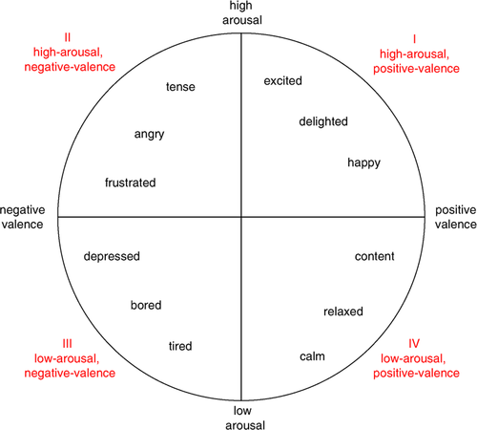](https://ietresearch.onlinelibrary.wiley.com/cms/asset/61ed8e39-aa60-440a-afbf-897e7d4d22cf/ell2bf07358-fig-0001-m.jpg)

**Fig. 1**

The study consists of four stages. In the first step, EEG signals were collected from the GAMEEMO data set. In the second step, the spectral entropy values of each EEG signal were calculated. Then these values were classified with the bidirectional long-short term memory (BiLSTM) deep-learning model and the prediction process was carried out. In the last stage, the performance of the BiLSTM model is measured with different evaluation metrics.

The main contributions of the study can be summarised as follows:

* To the best of our knowledge, the GAMEEMO data set was analysed for the first time in this study with the BiLSTM deep-learning model.
* With this study, it was observed that EEG signals obtained from a portable device can also be used for emotion analysis.

The rest of the work is organized as follows: studies conducted with EEG signals are mentioned in the related works section. In the data and methods section, general information about the data set, the spectral entropy and BiLSTM model used in this study are given. In the application results section, the performance of the BiLSTM model was examined and the results were discussed. In the conclusion section, the study was examined and explanations were made based on possible future applications.

Data set and methods

In this study, EEG signals belonging to the GAMEEMO [[**14**](https://ietresearch.onlinelibrary.wiley.com/doi/10.1049/el.2020.2460#ell2bf07358-bib-0014) ] data set are used. The data set contains EEG signals of 28 people. Unlike conventional EEG collecting devices, the data were obtained with a portable EEG device (Emotiv EPOC + 14-Channel Wireless EEG Headset). The EEG device used has 14 channels in total as AF3, AF4, F3, F4, F7, F8, FC5, FC6, O1, O2, P7, P8, T7 and T8. The sampling rate of the obtained signals is 128 Hz. The data set contains raw and preprocessed signals. Since noise-free data were used in this study, pre-processed data were considered.

|  |  |  |  |  |  |
| --- | --- | --- | --- | --- | --- |
| **Dataset** | **Subject** | **EEG Channels** | **Sample** | **EED Data** | **Games** |
| GAMEEMO | 28 | 14 | 38252 | 1568 | 4 |

In order to obtain emotions, the subjects played four computer games and each subject played games for 5 min. There are a total of 1568 (4 × 14 × 28) EEG data in the data set. The number 4 refers to the stimuli used. This value is 4 because 4 games were played in the data set. The number 14 indicates the number of EEG channels, while number 28 refers to the subjects. Sample length of each EEG data is 38,252. More technical and detailed information about the data set can be obtained from [14]. Researchers who want to use GAMEEMO data can access the data from the link provided ([**https://data.mendeley.com/datasets/b3pn4kwpmn/3**](https://data.mendeley.com/datasets/b3pn4kwpmn/3) ).

In this study, recurrent neural network was used instead of traditional CNN architectures because of their success in time series applications [20-22]. For this reason, a recurrent neural network model – bidirectional LSTM, was used in the proposed study. Bidirectional LSTMs are an extension of the LSTM model and have been proposed to improve model performance in classification problems. In the BiLSTM architecture, input values train two LSTMs instead of one. Therefore, information flows both from the past to the future and from the future to the past. In traditional LSTM architectures, information from the future is evaluated and preserved, while in BLSTM architecture, information from both the past and the future is preserved and valued. Owing to this advantage, BiLSTM is more successful than LSTM [23]. Thus, BiLSTM is considered in the study. The graphical abstract of the study is

[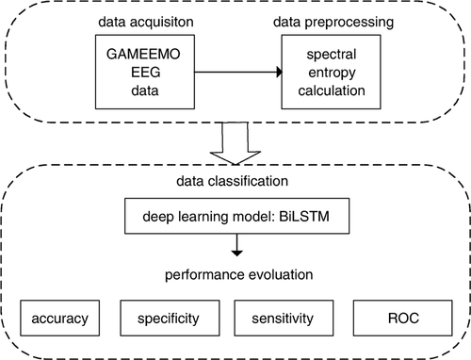](https://ietresearch.onlinelibrary.wiley.com/cms/asset/9977758c-7ae2-48aa-b340-6f93f9faf59e/ell2bf07358-fig-0002-m.jpg)

Data Preprocessing

The given dataset is already available in the pre-processed form. The preprocessing has been done within a device while obtaining the EEG signals from the subjects. The signal bandwidth is 0.5 Hz to 45 HZ. This range of bandwidth was obtained by applying the high and low frequency filter. In this dataset, the maximum frequency is 45 Hz and the minimum frequency is 0.5 Hz. In our case, will use the pre-process dataset which is in .csv format for the project.

Table 2 Positive – Negative and Arousal – Valence Model

|  |  |
| --- | --- |
| **Games** | **Emotion Type** |
| G1 | Boring |
| G2 | Calm |
| G3 | Horror |
| G4 | Funny |

Data classification

The data set contains EEG signals of 28 people. Subjects played four computer emotionally 4 different computer games (boring, calm, horror and funny) for 5 minutes and totally 20 minutes long eeg data available. Games are represented as G1, G2, G3 and G4. G1 refers game 1 which is boring emotions, G2 refers game 2 which is calm emotions, G3 refers game 3 which is horror emotions and G3 refers game 3 which is funny emotions. In this experiment, the supervised learning classification model will be used to classify human emotion using the EEG signals. Here we classified our data both binary classification and multiclassification.

Binary Classification

For all 28 subjects G1 refers for game 1 which are boring and other game G2, G3, G4 are not boring emotions, G2 refers for game 2 which are calm and other game G1, G3, G4 are not calm emotions, G3 refers for game 3 which are horror and other game G1, G2, G4 are not horror emotions, G4 refers for game 4 which are funny and other G1, G2, G3 are not funny emotions.

This Classification for boring emotions

|  |  |  |  |
| --- | --- | --- | --- |
| **Game** | **Emotion** | **Divided Subjects** | **Label** |
| G1 | Boring | 28 | 1 |
| G2 | Not boring | 9 | 0 |
| G3 | Not boring | 9 | 0 |
| G4 | Not boring | 10 | 0 |

This Classification for calm emotions

|  |  |  |  |  |
| --- | --- | --- | --- | --- |
| **Game** | **Emotion** | **Divided Subjects** | | **Label** |
| G1 | Not calm | 10 | 0 | |
| G2 | Calm | 28 | 1 | |
| G3 | Not calm | 9 | 0 | |
| G4 | Not calm | 9 | 0 | |

This classification for horror emotions

|  |  |  |  |
| --- | --- | --- | --- |
| **Game** | **Emotion** | **Divided Subjects** | **Label** |
| G1 | Not horror | 10 | 0 |
| G2 | Not horror | 9 | 0 |
| G3 | Horror | 28 | 1 |
| G4 | Not horror | 9 | 0 |

This Classification for funny emotions

|  |  |  |  |
| --- | --- | --- | --- |
| **Game** | **Emotion** | **Divided Subjects** | **Label** |
| G1 | Not funny | 10 | 0 |
| G2 | Not funny | 9 | 0 |
| G3 | Not funny | 9 | 0 |
| G4 | Funny | 28 | 1 |

Multiclasification

For all 28 subjects we have already known that G1 refers game 1 which is boring. Similarly, we will understand for other games G2, G3, G4.

This table for Multiclassification

|  |  |  |  |
| --- | --- | --- | --- |
| **Game** | **Emotion** | **Divided Subjects** | **Label** |
| G1 | Boring | 28 | 0 |
| G2 | Calm | 28 | 1 |
| G3 | Horror | 28 | 2 |
| G4 | Funny | 28 | 3 |

Long Short Term Memory

Introduction

In sequence prediction challenges, Long Short Term Memory (LSTM) networks are a type of Recurrent Neural Network that can learn order dependence. The output of the previous step is used as input in the current step in RNN. Hochreiter & Schmidhuber created the LSTM. It addressed the issue of RNN long-term dependency, in which the RNN is unable to predict words stored in long-term memory but can make more accurate predictions based on current data. RNN does not provide an efficient performance as the gap length rises. The LSTM may keep information for a long time by default. It is used for time-series data processing, prediction, and classification.

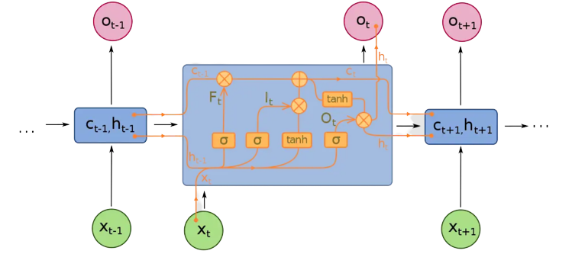

LSTM has feedback connections, unlike conventional feed-forward neural networks. It can handle not only single data points (like photos) but also complete data streams (such as speech or video). LSTM can be used for tasks like unsegmented, linked handwriting recognition, or speech recognition.

Structure Of LSTM

The LSTM is made up of four neural networks and numerous memory blocks known as cells in a chain structure. A conventional LSTM unit consists of a cell, an input gate, an output gate, and a forget gate. The flow of information into and out of the cell is controlled by three gates, and the cell remembers values over arbitrary time intervals. The LSTM algorithm is well adapted to categorize, analyze, and predict time series of uncertain duration.

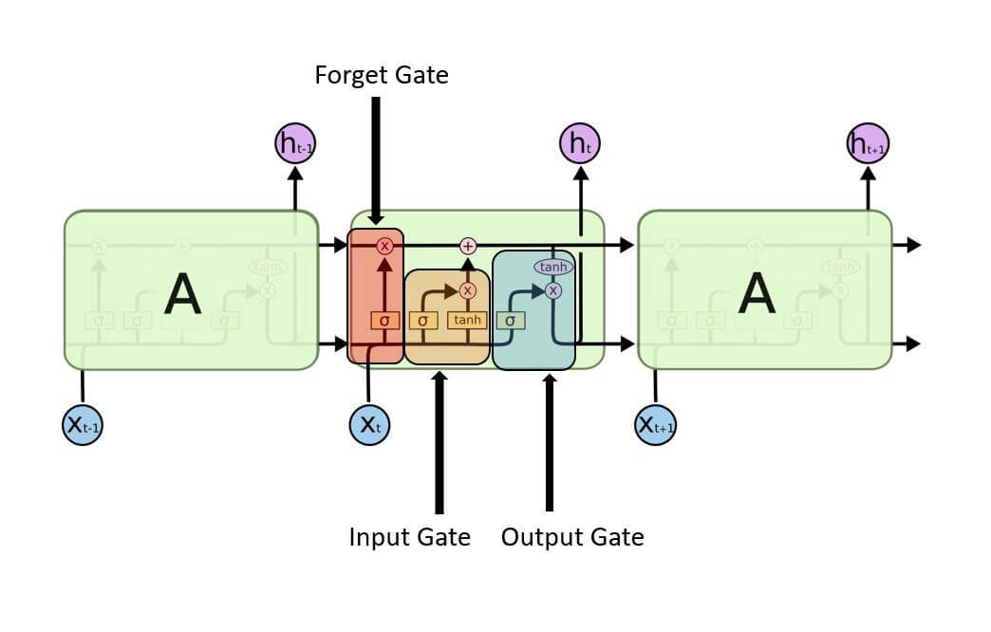

The cells store information, whereas the gates manipulate memory. There are three entrances:

* **Input Gate:** It determines which of the input values should be used to change the memory. The **sigmoid** function determines whether to allow 0 or 1 values through. And the**tanh** function assigns weight to the data provided, determining their importance on a scale of -1 to 1.

Input Gate | Long Short Term Memory

* **Forget Gate:**It finds the details that should be removed from the block. It is decided by a**sigmoid**function. For each number in the cell state Ct-1, it looks at the preceding state (ht-1) and the content input (Xt) and produces a number between 0 (omit this) and 1 (keep this).

Forget Gate | Long Short Term Memory

* **Output Gate:**The block’s input and memory are used to determine the output. The **sigmoid** function determines whether to allow 0 or 1 values through. And the **tanh** function determines which values are allowed to pass through 0, 1. And the **tanh** function assigns weight to the values provided, determining their relevance on a scale of -1 to 1 and multiplying it with the sigmoid output.

Output Gate 

The recurrent neural network uses long short-term memory blocks to provide context for how the software accepts inputs and creates outputs. Because the program uses a structure based on short-term memory processes to build longer-term memory, the unit is dubbed a long short-term memory block. In natural language processing, these systems are extensively used.

**For example,**The recurrent neural network makes use of long short-term memory blocks to evaluate a single word or phoneme in the context of others in a string, where memory can aid in the filtering and categorization of certain types of data. In general, LSTM is a well-known and widely used idea in the development of recurrent neural networks.

**LSTM Networks**

A sequence of repeating neural network modules makes up all recurrent neural networks. This repeating module in traditional RNNs will have a simple structure, such as a single tanh layer.

The output of the current time step becomes the input for the following time step, which is referred to as Recurrent. At each element of the sequence, the model examines not just the current input, but also what it knows about the prior ones.

A single layer exists in the repeating module of a conventional RNN:

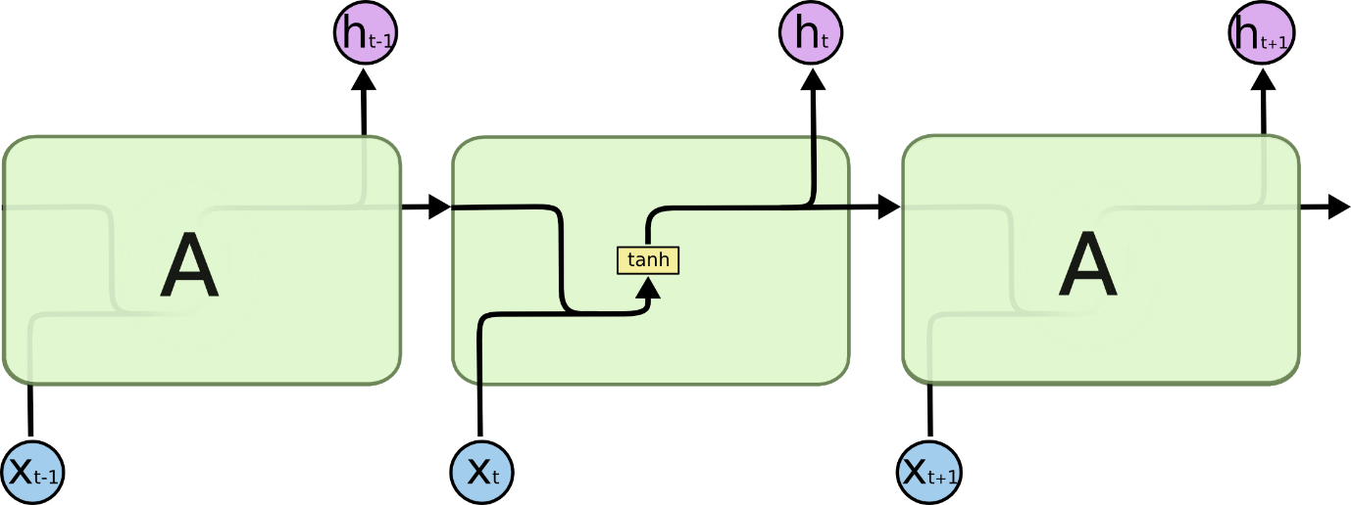

Source: Colah.com

An LSTM’s repeating module is made up of four layers that interact with one another:

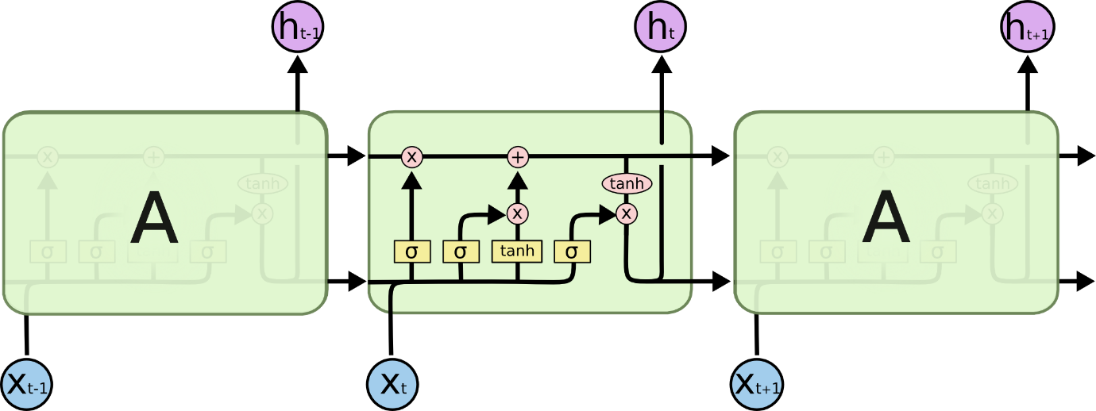

Source: Colah.com

* The cell state, represented by the horizontal line at the top of the diagram, is crucial to LSTMs.
* The state of the cell resembles that of a conveyor belt in certain ways. There are only a few tiny linear interactions as it travels down the entire chain. It’s quite easy for data to simply travel down it without being altered.
* The LSTM can delete or add information to the cell state, which is carefully controlled by structures called gates.
* Gates are a mechanism to selectively allow information to pass through. A sigmoid neural net layer plus a pointwise multiplication operation make them up.
* The sigmoid layer produces integers ranging from zero to one, indicating how much of each component should be allowed to pass. A value of zero indicates that “nothing” should be allowed through, whereas a value of one indicates that “everything” should be allowed through.
* Three of these gates are present in an LSTM to protect and govern the cell state.

**LSTM Cycle**

The LSTM cycle is divided into four steps:

* Using the forget gate, information to be forgotten is identified from a prior time step.
* Using input gate and tanh, new information is sought for updating cell state.
* The information from the two gates above is used to update the cell state.
* The output gate and the squashing operation provide useful information.

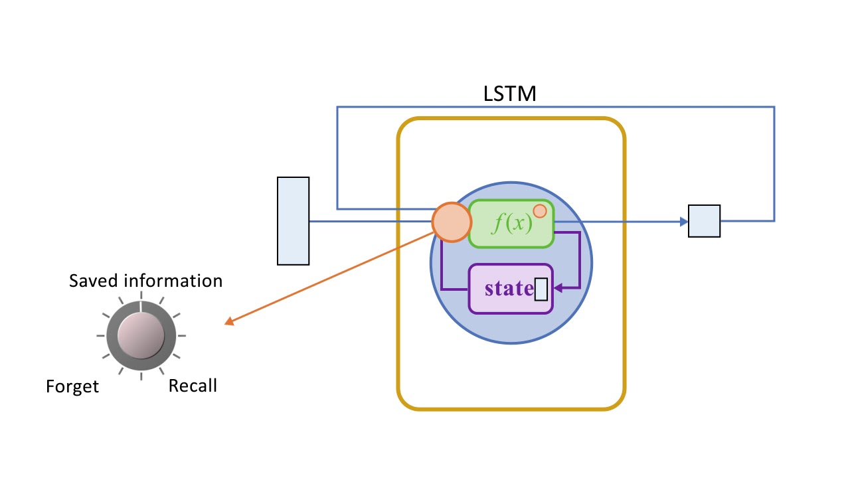

A dense layer receives the output of an LSTM cell. After the dense layer, the output stage is given the softmax activation function.

Bidirectional LSTM

Now, when we are dealing with long sequences of data and the model is required to learn relationship between future and past word as well. we need to send data in that manner. To solve this problem bidirectional network was introduced. In bidirectional LSTM we give the input from both the directions from right to left and from left to right . Make a note this is not a backward propagation this is only the input which is given from both the side.So, the question is how the data is combined in output if we are having 2 inputs.

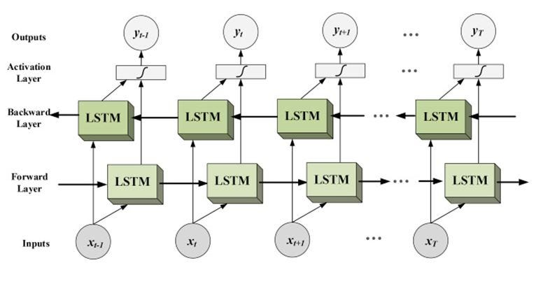

Generally in normal LSTM network we take output directly as shown in first figure but in bidirectional LSTM network output of forward and backward layer at each stage is given to activation layer which is a neural network and output of this activation layer is considered. This output contains the information or relation of past and future word also.

Application Results

In this study, the EEG signals of the GAMEEMO data set were classified and positive–negative emotions were predicted. BiLSTM was used for the classification process and the performance of the deep-learning model was measured with accuracy, sensitivity, specificity and receiver operating characteristic (ROC) values. The parameters of the developed BiLSTM model can be summarised as follows:

* EEG data, whose spectral entropy values were calculated, were used in the input layer.
* Then the 128-unit BiLSTM layer was designed. softmax function was used as an activation function.
* Then, the data were transformed into a one-dimensional vector by the flattening process.
* Later, the batch normalisation was performed and the data were normalised.
* Dropout was used to prevent overfitting problem and its degree was set to 0.20.
* In the classification Finally, a fully connected layer was designed the softmax function has been used and the binary classification process has been made.
* Stochastic gradient descent was applied as an optimiser with default values.
* The loss of the model was calculated by binary cross-entropy.
* The epoch value was chosen to be 50.
* To validate the model, the train-test split approach was used and 80% of the data was used for training and 20% for testing.
* All of these parameters were determined by trial and error approach and the parameters giving the best result were used in the study.
* Table 1 shows the classification results of the BiLSTM model.

Game (G1)

Model: "sequential_15"

_________________________________________________________________

Layer (type) Output Shape Param #

=================================================================

bidirectional_10 (Bidirecti (None, 640, 256) 146432

onal)

dropout_20 (Dropout) (None, 640, 256) 0

bidirectional_11 (Bidirecti (None, 128) 164352

onal)

dropout_21 (Dropout) (None, 128) 0

dense_10 (Dense) (None, 1) 129

=================================================================

Total params: 310,913

Trainable params: 310,913

Non-trainable params: 0

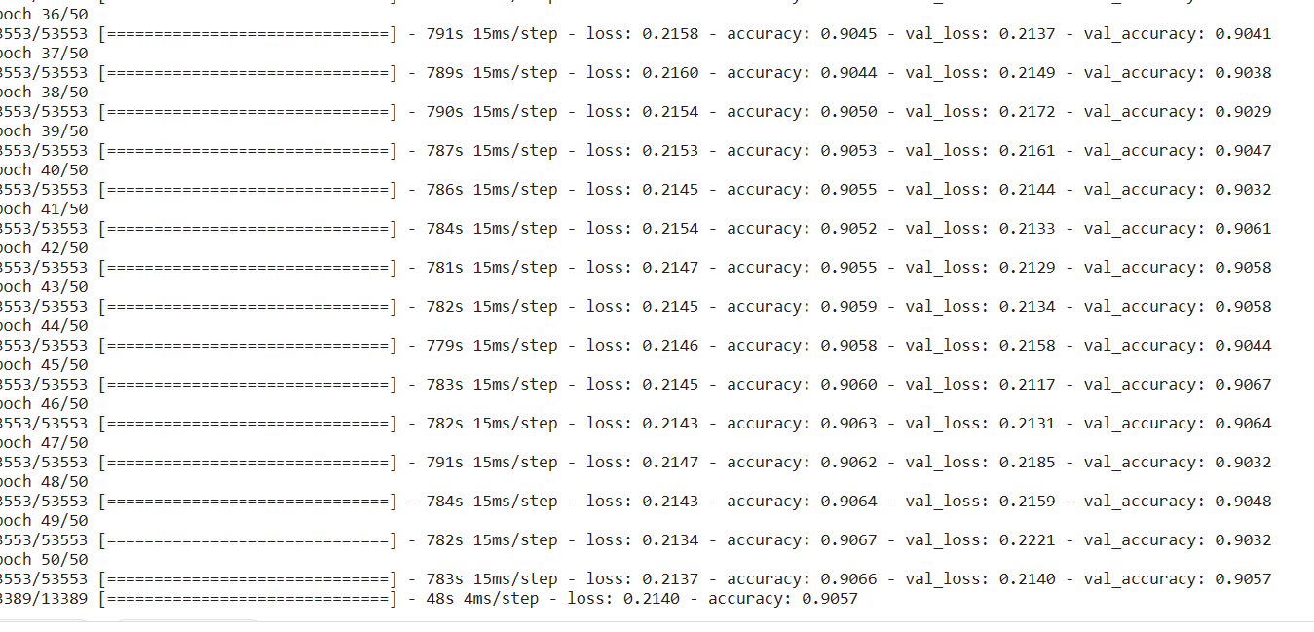

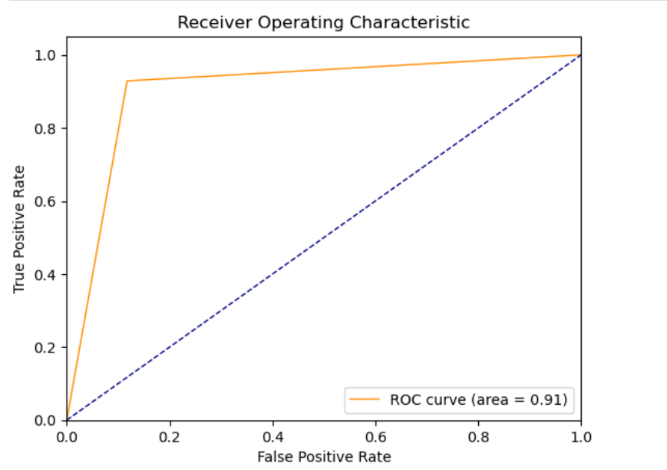

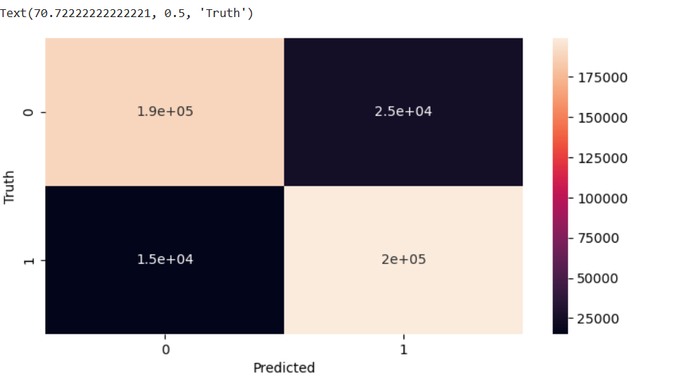

|  |  |  |
| --- | --- | --- |
| Classification | Games | Bidirectional Accuracy |
| Binary | G1 | 90.57% |
| Binary | G2 | 90.92% |
| Binary | G3 | 90.78% |
| Binary | G4 | 89.29% |
| Multi | G1, G2, G3, G4 | 85.34% |

Conclusion

In this study, positive and negative emotions were analysed using the EEG data of the GAMEEMO data set. In the first part of the study, pre-processed data were obtained from the data set. Then, spectral entropy values were collected from the data of each EEG channel and these values were used in the BiLSTM model. In the final phase, the binary classification and multiclassification process was made with BiLSTM and the performance of the deep-learning model was measured with accuracy, ROC values, confusion matrix are 90.57% accuracy, Text (70.72222222222221, 0.5, 'Truth') and 90% ROC values were achieved for Game G1. Approximately achieved accuracy, confusion matrix and ROC value. For multiclassification accuracy was achieved 85.43%. Emotions was be examined with both binary-classification and multi-class classification. Emotions are of great importance in human life. In daily life, we use our emotions intentionally or unintentionally. Therefore, emotion analysis studies are important for understanding emotions and determining their behaviour.

Reference

* 1Naji M. Firoozabadi M. Azadfallah P.: ‘Emotion classification during music listening from forehead biosignals ’, *Signal. Image. Video. Process.*, 2015, 9, pp. 1365– 1375, doi: [10.1007/s11760-013-0591-6](https://doi.org/10.1007/s11760-013-0591-6)
  + View
  + Web of Science Google Scholar
* 2Alakus T.B. Turkoglu I.: ‘EEG based emotion analysis systems ’, *TBV J. Comput. Sci. Eng.*, 2018, 11, (1 ), pp. 26– 39
  + [Google Scholar](https://ietresearch.onlinelibrary.wiley.com/action/getFTRLinkout?url=http%3A%2F%2Fscholar.google.com%2Fscholar_lookup%3Fhl%3Den%26volume%3D11%26publication_year%3D2018%26pages%3D26-39%26journal%3DTBV%2BJ.%2BComput.%2BSci.%2BEng.%26issue%3D1%26author%3DT.B.%2BAlakus%26author%3DI.%2BTurkoglu%26title%3DEEG%2Bbased%2Bemotion%2Banalysis%2Bsystems&doi=10.1049%2Fel.2020.2460&linkType=gs&linkLocation=Reference&linkSource=FULL_TEXT)
* 3Michalopoulos K. Bourbakis N.: ‘Application of multiscale entropy on EEG signals for emotion detection ’. IEEE EMBS Int. Conf. Information Technology Applications in Biomedicine, Orlando, FL, USA, February 2017, pp. 341– 344, doi: [10.1109/BHI.2017.7897275](https://doi.org/10.1109/BHI.2017.7897275)
  + [Google Scholar](https://ietresearch.onlinelibrary.wiley.com/action/getFTRLinkout?url=http%3A%2F%2Fscholar.google.com%2Fscholar_lookup%3Fhl%3Den%26publication_year%3DFebruary%2B2017%26author%3DK.%2BMichalopoulos%26author%3DN.%2BBourbakis%26title%3DApplication%2Bof%2Bmultiscale%2Bentropy%2Bon%2BEEG%2Bsignals%2Bfor%2Bemotion%2Bdetection&doi=10.1049%2Fel.2020.2460&linkType=gs&linkLocation=Reference&linkSource=FULL_TEXT)
* 4Alakus T.B. Turkoglu I.: ‘Feature selection with sequential forward selection algorithm from emotion estimation based on EEG signals ’, *Sakarya Univ. J. Sci.*, 2019, 23, (6 ), pp. 1096– 1105, doi: [10.16984/saufenbilder.501799](https://doi.org/10.16984/saufenbilder.501799)
  + View
  + [Google Scholar](https://ietresearch.onlinelibrary.wiley.com/action/getFTRLinkout?url=http%3A%2F%2Fscholar.google.com%2Fscholar_lookup%3Fhl%3Den%26volume%3D23%26publication_year%3D2019%26pages%3D1096-1105%26journal%3DSakarya%2BUniv.%2BJ.%2BSci.%26issue%3D6%26author%3DT.B.%2BAlakus%26author%3DI.%2BTurkoglu%26title%3DFeature%2Bselection%2Bwith%2Bsequential%2Bforward%2Bselection%2Balgorithm%2Bfrom%2Bemotion%2Bestimation%2Bbased%2Bon%2BEEG%2Bsignals&doi=10.1049%2Fel.2020.2460&doiOfLink=10.16984%2Fsaufenbilder.501799&linkType=gs&linkLocation=Reference&linkSource=FULL_TEXT)
* 5Turnip A. Simbolon A.I. Amri M.F. *et al.*: ‘Backpropagation neural networks training for EEG-SSVEP classification of emotion recognition ’, *Internetwork. Indonesia J.*, 2017, 9, (1 ), pp. 53– 57
  + [Web of Science®](https://ietresearch.onlinelibrary.wiley.com/servlet/linkout?suffix=null&dbid=128&doi=10.1049%2Fel.2020.2460&key=000417365300010&getFTLinkType=true&doiForPubOfPage=10.1049%2Fel.2020.2460&refDoi=e_1_2_6_6_2:ISI&linkType=ISI&linkSource=FULL_TEXT&linkLocation=Reference)[Google Scholar](https://ietresearch.onlinelibrary.wiley.com/action/getFTRLinkout?url=http%3A%2F%2Fscholar.google.com%2Fscholar_lookup%3Fhl%3Den%26volume%3D9%26publication_year%3D2017%26pages%3D53-57%26journal%3DInternetwork.%2BIndonesia%2BJ.%26issue%3D1%26author%3DA.%2BTurnip%26author%3DA.I.%2BSimbolon%26author%3DM.F.%2BAmri%26title%3DBackpropagation%2Bneural%2Bnetworks%2Btraining%2Bfor%2BEEG%25E2%2580%2590SSVEP%2Bclassification%2Bof%2Bemotion%2Brecognition&doi=10.1049%2Fel.2020.2460&linkType=gs&linkLocation=Reference&linkSource=FULL_TEXT)
* 6Alakus T.B. Turkoglu I.: ‘Determination of effective EEG channels for discrimination of positive and negative emotions with wavelet decomposition and support vector machines ’, *Int. J. Inform. Technol.*, 2019, 12, (3 ), pp. 229– 237
  + [Google Scholar](https://ietresearch.onlinelibrary.wiley.com/action/getFTRLinkout?url=http%3A%2F%2Fscholar.google.com%2Fscholar_lookup%3Fhl%3Den%26volume%3D12%26publication_year%3D2019%26pages%3D229-237%26journal%3DInt.%2BJ.%2BInform.%2BTechnol.%26issue%3D3%26author%3DT.B.%2BAlakus%26author%3DI.%2BTurkoglu%26title%3DDetermination%2Bof%2Beffective%2BEEG%2Bchannels%2Bfor%2Bdiscrimination%2Bof%2Bpositive%2Band%2Bnegative%2Bemotions%2Bwith%2Bwavelet%2Bdecomposition%2Band%2Bsupport%2Bvector%2Bmachines&doi=10.1049%2Fel.2020.2460&linkType=gs&linkLocation=Reference&linkSource=FULL_TEXT)
* 7Yan J. Chen S. Deng S.: ‘A EEG-based emotion recognition model with rhythm and time characteristics ’, *Brain. Inform.*, 2019, 6, (1 ), pp. 1– 8, doi: [10.1186/s40708-019-0100-y](https://doi.org/10.1186/s40708-019-0100-y)
  + [PubMed](https://ietresearch.onlinelibrary.wiley.com/servlet/linkout?suffix=null&dbid=8&doi=10.1049%2Fel.2020.2460&key=30706237&getFTLinkType=true&doiForPubOfPage=10.1049%2Fel.2020.2460&refDoi=10.1186/s40708%E2%80%90019%E2%80%900100%E2%80%90y&linkType=PMID&linkSource=FULL_TEXT&linkLocation=Reference)[Google Scholar](https://ietresearch.onlinelibrary.wiley.com/action/getFTRLinkout?url=http%3A%2F%2Fscholar.google.com%2Fscholar_lookup%3Fhl%3Den%26volume%3D6%26publication_year%3D2019%26pages%3D1-8%26journal%3DBrain.%2BInform.%26issue%3D1%26author%3DJ.%2BYan%26author%3DS.%2BChen%26author%3DS.%2BDeng%26title%3DA%2BEEG%25E2%2580%2590based%2Bemotion%2Brecognition%2Bmodel%2Bwith%2Brhythm%2Band%2Btime%2Bcharacteristics&doi=10.1049%2Fel.2020.2460&doiOfLink=10.1186%2Fs40708%E2%80%90019%E2%80%900100%E2%80%90y&linkType=gs&linkLocation=Reference&linkSource=FULL_TEXT)
* 8Pan J. Li Y. Wang J.: ‘An EEG-based brain-computer interface for emotion recognition ’. Int. Joint Conf. Neural Networks, Vancouver, BC, Canada, July 2016, pp. 2063– 2067, doi: [10.1109/IJCNN.2016.7727453](https://doi.org/10.1109/IJCNN.2016.7727453)
  + [Google Scholar](https://ietresearch.onlinelibrary.wiley.com/action/getFTRLinkout?url=http%3A%2F%2Fscholar.google.com%2Fscholar_lookup%3Fhl%3Den%26publication_year%3DJuly%2B2016%26author%3DJ.%2BPan%26author%3DY.%2BLi%26author%3DJ.%2BWang%26title%3DAn%2BEEG%25E2%2580%2590based%2Bbrain%25E2%2580%2590computer%2Binterface%2Bfor%2Bemotion%2Brecognition&doi=10.1049%2Fel.2020.2460&linkType=gs&linkLocation=Reference&linkSource=FULL_TEXT)
* 9Mason W.A. Capitanio J.P.: ‘Basic emotions: a reconstruction ’, *Emot. Rev.*, 2012, 4, (3 ), pp. 238– 244, doi: [10.1177/1754073912439763](https://doi.org/10.1177/1754073912439763)
  + [PubMed](https://ietresearch.onlinelibrary.wiley.com/servlet/linkout?suffix=null&dbid=8&doi=10.1049%2Fel.2020.2460&key=27110280&getFTLinkType=true&doiForPubOfPage=10.1049%2Fel.2020.2460&refDoi=10.1177/1754073912439763&linkType=PMID&linkSource=FULL_TEXT&linkLocation=Reference)[Web of Science®](https://ietresearch.onlinelibrary.wiley.com/servlet/linkout?suffix=null&dbid=128&doi=10.1049%2Fel.2020.2460&key=000306277100007&getFTLinkType=true&doiForPubOfPage=10.1049%2Fel.2020.2460&refDoi=10.1177/1754073912439763&linkType=ISI&linkSource=FULL_TEXT&linkLocation=Reference)[Google Scholar](https://ietresearch.onlinelibrary.wiley.com/action/getFTRLinkout?url=http%3A%2F%2Fscholar.google.com%2Fscholar_lookup%3Fhl%3Den%26volume%3D4%26publication_year%3D2012%26pages%3D238-244%26journal%3DEmot.%2BRev.%26issue%3D3%26author%3DW.A.%2BMason%26author%3DJ.P.%2BCapitanio%26title%3DBasic%2Bemotions%253A%2Ba%2Breconstruction&doi=10.1049%2Fel.2020.2460&doiOfLink=10.1177%2F1754073912439763&linkType=gs&linkLocation=Reference&linkSource=FULL_TEXT)
* 10Russel A.: ‘Core affect and psychological construction of emotion ’, *Psychol. Rev.*, 2003, 110, (1 ), pp. 145– 150
  + [PubMed](https://ietresearch.onlinelibrary.wiley.com/servlet/linkout?suffix=null&dbid=8&doi=10.1049%2Fel.2020.2460&key=12529060&getFTLinkType=true&doiForPubOfPage=10.1049%2Fel.2020.2460&refDoi=10.1037/0033-295X.110.1.145&linkType=PMID&linkSource=FULL_TEXT&linkLocation=Reference)[Web of Science®](https://ietresearch.onlinelibrary.wiley.com/servlet/linkout?suffix=null&dbid=128&doi=10.1049%2Fel.2020.2460&key=000180095900005&getFTLinkType=true&doiForPubOfPage=10.1049%2Fel.2020.2460&refDoi=10.1037/0033-295X.110.1.145&linkType=ISI&linkSource=FULL_TEXT&linkLocation=Reference)[Google Scholar](https://ietresearch.onlinelibrary.wiley.com/action/getFTRLinkout?url=http%3A%2F%2Fscholar.google.com%2Fscholar_lookup%3Fhl%3Den%26volume%3D110%26publication_year%3D2003%26pages%3D145-150%26journal%3DPsychol.%2BRev.%26issue%3D1%26author%3DA.%2BRussel%26title%3DCore%2Baffect%2Band%2Bpsychological%2Bconstruction%2Bof%2Bemotion&doi=10.1049%2Fel.2020.2460&doiOfLink=10.1037%2F0033-295X.110.1.145&linkType=gs&linkLocation=Reference&linkSource=FULL_TEXT)
* 11Alhagry S. Fahmy A.A. El-Khoribi R.A.: ‘Emotion recognition based on EEG using LSTM recurrent neural network ’, *Int. J. Adv. Comput. Sci. Appl.*, 2017, 8, (10 ), pp. 355– 358, doi: [10.14569/IJACSA.2017.081046](https://doi.org/10.14569/IJACSA.2017.081046)
  + [Web of Science®](https://ietresearch.onlinelibrary.wiley.com/servlet/linkout?suffix=null&dbid=128&doi=10.1049%2Fel.2020.2460&key=000416609500047&getFTLinkType=true&doiForPubOfPage=10.1049%2Fel.2020.2460&refDoi=10.14569/IJACSA.2017.081046&linkType=ISI&linkSource=FULL_TEXT&linkLocation=Reference)[Google Scholar](https://ietresearch.onlinelibrary.wiley.com/action/getFTRLinkout?url=http%3A%2F%2Fscholar.google.com%2Fscholar_lookup%3Fhl%3Den%26volume%3D8%26publication_year%3D2017%26pages%3D355-358%26journal%3DInt.%2BJ.%2BAdv.%2BComput.%2BSci.%2BAppl.%26issue%3D10%26author%3DS.%2BAlhagry%26author%3DA.A.%2BFahmy%26author%3DR.A.%2BEl%25E2%2580%2590Khoribi%26title%3DEmotion%2Brecognition%2Bbased%2Bon%2BEEG%2Busing%2BLSTM%2Brecurrent%2Bneural%2Bnetwork&doi=10.1049%2Fel.2020.2460&doiOfLink=10.14569%2FIJACSA.2017.081046&linkType=gs&linkLocation=Reference&linkSource=FULL_TEXT)
* 12Pandey P. Seeja K.R.: ‘Subject independent emotion recognition from EEG using VMD and deep learning ’, *J. King Saud Univ. – Comput. Inform. Sci.*, 2019, 2019, pp. 53– 58, doi: [10.1016/j.jksuci.2019.11.003](https://doi.org/10.1016/j.jksuci.2019.11.003)
  + [Google Scholar](https://ietresearch.onlinelibrary.wiley.com/action/getFTRLinkout?url=http%3A%2F%2Fscholar.google.com%2Fscholar_lookup%3Fhl%3Den%26volume%3D2019%26publication_year%3D2019%26pages%3D53-58%26journal%3DJ.%2BKing%2BSaud%2BUniv.%2B%25E2%2580%2593%2BComput.%2BInform.%2BSci.%26author%3DP.%2BPandey%26author%3DK.R.%2BSeeja%26title%3DSubject%2Bindependent%2Bemotion%2Brecognition%2Bfrom%2BEEG%2Busing%2BVMD%2Band%2Bdeep%2Blearning&doi=10.1049%2Fel.2020.2460&doiOfLink=10.1016%2Fj.jksuci.2019.11.003&linkType=gs&linkLocation=Reference&linkSource=FULL_TEXT)
* 13Jirayucharoensak S. Pan-Ngum S. Israsena P.: ‘EEG-based emotion recognition using deep learning network with principal component based covariate shift adaptation ’, *Sci. World J.*, 2014, 2014, pp. 1– 10, 627892, doi: [10.1155/2014/627892](https://doi.org/10.1155/2014/627892)
  + [Web of Science®](https://ietresearch.onlinelibrary.wiley.com/servlet/linkout?suffix=null&dbid=128&doi=10.1049%2Fel.2020.2460&key=000343573200001&getFTLinkType=true&doiForPubOfPage=10.1049%2Fel.2020.2460&refDoi=10.1155/2014/627892&linkType=ISI&linkSource=FULL_TEXT&linkLocation=Reference)[Google Scholar](https://ietresearch.onlinelibrary.wiley.com/action/getFTRLinkout?url=http%3A%2F%2Fscholar.google.com%2Fscholar_lookup%3Fhl%3Den%26volume%3D2014%26publication_year%3D2014%26pages%3D1-10%26journal%3DSci.%2BWorld%2BJ.%26author%3DS.%2BJirayucharoensak%26author%3DS.%2BPan%25E2%2580%2590Ngum%26author%3DP.%2BIsrasena%26title%3DEEG%25E2%2580%2590based%2Bemotion%2Brecognition%2Busing%2Bdeep%2Blearning%2Bnetwork%2Bwith%2Bprincipal%2Bcomponent%2Bbased%2Bcovariate%2Bshift%2Badaptation&doi=10.1049%2Fel.2020.2460&doiOfLink=10.1155%2F2014%2F627892&linkType=gs&linkLocation=Reference&linkSource=FULL_TEXT)
* 14Alakus T.B. Gonen M. Turkoglu I.: ‘Database for an emotion recognition system based on EEG signals and various computer games – GAMEEMO ’, *Biomed. Signal Proc. Control*, 2020, 60, pp. 1– 12, doi: [10.1016/j.bspc.2020.101951](https://doi.org/10.1016/j.bspc.2020.101951)
  + [Web of Science®](https://ietresearch.onlinelibrary.wiley.com/servlet/linkout?suffix=null&dbid=128&doi=10.1049%2Fel.2020.2460&key=000540302000012&getFTLinkType=true&doiForPubOfPage=10.1049%2Fel.2020.2460&refDoi=10.1016/j.bspc.2020.101951&linkType=ISI&linkSource=FULL_TEXT&linkLocation=Reference)[Google Scholar](https://ietresearch.onlinelibrary.wiley.com/action/getFTRLinkout?url=http%3A%2F%2Fscholar.google.com%2Fscholar_lookup%3Fhl%3Den%26volume%3D60%26publication_year%3D2020%26pages%3D1-12%26journal%3DBiomed.%2BSignal%2BProc.%2BControl%26author%3DT.B.%2BAlakus%26author%3DM.%2BGonen%26author%3DI.%2BTurkoglu%26title%3DDatabase%2Bfor%2Ban%2Bemotion%2Brecognition%2Bsystem%2Bbased%2Bon%2BEEG%2Bsignals%2Band%2Bvarious%2Bcomputer%2Bgames%2B%25E2%2580%2593%2BGAMEEMO&doi=10.1049%2Fel.2020.2460&doiOfLink=10.1016%2Fj.bspc.2020.101951&linkType=gs&linkLocation=Reference&linkSource=FULL_TEXT)
* 15Vanluchene A.L.G. Vereecke H. Thas O. *et al.*: ‘Spectral entropy as an electroencephalographic measure of anesthetic drug effect: a comparison with bispectral index and processed midlatency auditory evoked response ’, *Anesthesiology*, 2004, 101, (1 ), pp. 34– 42
  + [CAS](https://ietresearch.onlinelibrary.wiley.com/servlet/linkout?suffix=null&dbid=32&doi=10.1049%2Fel.2020.2460&key=1%3ACAS%3A528%3ADC%252BD2cXlt1SksLw%253D&getFTLinkType=true&doiForPubOfPage=10.1049%2Fel.2020.2460&refDoi=10.1097/00000542-200407000-00008&linkType=COI&linkSource=FULL_TEXT&linkLocation=Reference)[PubMed](https://ietresearch.onlinelibrary.wiley.com/servlet/linkout?suffix=null&dbid=8&doi=10.1049%2Fel.2020.2460&key=15220769&getFTLinkType=true&doiForPubOfPage=10.1049%2Fel.2020.2460&refDoi=10.1097/00000542-200407000-00008&linkType=PMID&linkSource=FULL_TEXT&linkLocation=Reference)[Web of Science®](https://ietresearch.onlinelibrary.wiley.com/servlet/linkout?suffix=null&dbid=128&doi=10.1049%2Fel.2020.2460&key=000222281200007&getFTLinkType=true&doiForPubOfPage=10.1049%2Fel.2020.2460&refDoi=10.1097/00000542-200407000-00008&linkType=ISI&linkSource=FULL_TEXT&linkLocation=Reference)[Google Scholar](https://ietresearch.onlinelibrary.wiley.com/action/getFTRLinkout?url=http%3A%2F%2Fscholar.google.com%2Fscholar_lookup%3Fhl%3Den%26volume%3D101%26publication_year%3D2004%26pages%3D34-42%26journal%3DAnesthesiology%26issue%3D1%26author%3DA.L.G.%2BVanluchene%26author%3DH.%2BVereecke%26author%3DO.%2BThas%26title%3DSpectral%2Bentropy%2Bas%2Ban%2Belectroencephalographic%2Bmeasure%2Bof%2Banesthetic%2Bdrug%2Beffect%253A%2Ba%2Bcomparison%2Bwith%2Bbispectral%2Bindex%2Band%2Bprocessed%2Bmidlatency%2Bauditory%2Bevoked%2Bresponse&doi=10.1049%2Fel.2020.2460&doiOfLink=10.1097%2F00000542-200407000-00008&linkType=gs&linkLocation=Reference&linkSource=FULL_TEXT)
* 16Pan Y.N. Chen J. Li X.L.: ‘Spectral entropy: a complementary index for rolling element bearing performance degradation assessment ’, *Proc. Inst. Mech. Eng. C, J. Mech. Eng. Sci.*, 2009, 223, (5 ), pp. 1223– 1231, doi: [10.1243/09544062JMES1224](https://doi.org/10.1243/09544062JMES1224)
  + [Web of Science®](https://ietresearch.onlinelibrary.wiley.com/servlet/linkout?suffix=null&dbid=128&doi=10.1049%2Fel.2020.2460&key=000266510700019&getFTLinkType=true&doiForPubOfPage=10.1049%2Fel.2020.2460&refDoi=10.1243/09544062JMES1224&linkType=ISI&linkSource=FULL_TEXT&linkLocation=Reference)[Google Scholar](https://ietresearch.onlinelibrary.wiley.com/action/getFTRLinkout?url=http%3A%2F%2Fscholar.google.com%2Fscholar_lookup%3Fhl%3Den%26volume%3D223%26publication_year%3D2009%26pages%3D1223-1231%26journal%3DProc.%2BInst.%2BMech.%2BEng.%2BC%252C%2BJ.%2BMech.%2BEng.%2BSci.%26issue%3D5%26author%3DY.N.%2BPan%26author%3DJ.%2BChen%26author%3DX.L.%2BLi%26title%3DSpectral%2Bentropy%253A%2Ba%2Bcomplementary%2Bindex%2Bfor%2Brolling%2Belement%2Bbearing%2Bperformance%2Bdegradation%2Bassessment&doi=10.1049%2Fel.2020.2460&doiOfLink=10.1243%2F09544062JMES1224&linkType=gs&linkLocation=Reference&linkSource=FULL_TEXT)
* 17Sharma V. Parey A.: ‘A review of gear fault diagnosis using various condition indicators ’, *Procedia Eng.*, 2016, 144, pp. 256– 263, doi: [10.1016/j.proeng.2016.05.131](https://doi.org/10.1016/j.proeng.2016.05.131)
  + [Google Scholar](https://ietresearch.onlinelibrary.wiley.com/action/getFTRLinkout?url=http%3A%2F%2Fscholar.google.com%2Fscholar_lookup%3Fhl%3Den%26volume%3D144%26publication_year%3D2016%26pages%3D256-263%26journal%3DProcedia%2BEng.%26author%3DV.%2BSharma%26author%3DA.%2BParey%26title%3DA%2Breview%2Bof%2Bgear%2Bfault%2Bdiagnosis%2Busing%2Bvarious%2Bcondition%2Bindicators&doi=10.1049%2Fel.2020.2460&doiOfLink=10.1016%2Fj.proeng.2016.05.131&linkType=gs&linkLocation=Reference&linkSource=FULL_TEXT)
* 18Majstorovic N. Andric M. Mikluc D.: ‘Entropy-based algorithm for speech recognition in noisy environment ’. Telecommunications Forum, Belgrade, Serbia, November 2011, pp. 667– 670, doi: [10.1109/TELFOR.2011.6143635](https://doi.org/10.1109/TELFOR.2011.6143635)
  + [Google Scholar](https://ietresearch.onlinelibrary.wiley.com/action/getFTRLinkout?url=http%3A%2F%2Fscholar.google.com%2Fscholar_lookup%3Fhl%3Den%26publication_year%3DNovember%2B2011%26author%3DN.%2BMajstorovic%26author%3DM.%2BAndric%26author%3DD.%2BMikluc%26title%3DEntropy%25E2%2580%2590based%2Balgorithm%2Bfor%2Bspeech%2Brecognition%2Bin%2Bnoisy%2Benvironment&doi=10.1049%2Fel.2020.2460&linkType=gs&linkLocation=Reference&linkSource=FULL_TEXT)
* 19Vakkuri A. Yli-Hankala A. Talja P. *et al.*: ‘Time-frequency balanced spectral entropy as a measure of anesthetic drug effect in central nervous system during sevoflurane, propofol, and thiopental anesthesia ’, *Acta Anaesthesiol. Scand.*, 2004, 48, (2 ), pp. 145– 153, doi: [10.1111/j.0001-5172.2004.00323.x](https://doi.org/10.1111/j.0001-5172.2004.00323.x)
  + [CAS](https://ietresearch.onlinelibrary.wiley.com/servlet/linkout?suffix=null&dbid=32&doi=10.1049%2Fel.2020.2460&key=1%3ACAS%3A528%3ADC%252BD2cXhvFSgsrs%253D&getFTLinkType=true&doiForPubOfPage=10.1049%2Fel.2020.2460&refDoi=10.1111/j.0001%E2%80%905172.2004.00323.x&linkType=COI&linkSource=FULL_TEXT&linkLocation=Reference)[PubMed](https://ietresearch.onlinelibrary.wiley.com/servlet/linkout?suffix=null&dbid=8&doi=10.1049%2Fel.2020.2460&key=14995935&getFTLinkType=true&doiForPubOfPage=10.1049%2Fel.2020.2460&refDoi=10.1111/j.0001%E2%80%905172.2004.00323.x&linkType=PMID&linkSource=FULL_TEXT&linkLocation=Reference)[Web of Science®](https://ietresearch.onlinelibrary.wiley.com/servlet/linkout?suffix=null&dbid=128&doi=10.1049%2Fel.2020.2460&key=000188353500002&getFTLinkType=true&doiForPubOfPage=10.1049%2Fel.2020.2460&refDoi=10.1111/j.0001%E2%80%905172.2004.00323.x&linkType=ISI&linkSource=FULL_TEXT&linkLocation=Reference)[Google Scholar](https://ietresearch.onlinelibrary.wiley.com/action/getFTRLinkout?url=http%3A%2F%2Fscholar.google.com%2Fscholar_lookup%3Fhl%3Den%26volume%3D48%26publication_year%3D2004%26pages%3D145-153%26journal%3DActa%2BAnaesthesiol.%2BScand.%26issue%3D2%26author%3DA.%2BVakkuri%26author%3DA.%2BYli%25E2%2580%2590Hankala%26author%3DP.%2BTalja%26title%3DTime%25E2%2580%2590frequency%2Bbalanced%2Bspectral%2Bentropy%2Bas%2Ba%2Bmeasure%2Bof%2Banesthetic%2Bdrug%2Beffect%2Bin%2Bcentral%2Bnervous%2Bsystem%2Bduring%2Bsevoflurane%252C%2Bpropofol%252C%2Band%2Bthiopental%2Banesthesia&doi=10.1049%2Fel.2020.2460&doiOfLink=10.1111%2Fj.0001%E2%80%905172.2004.00323.x&linkType=gs&linkLocation=Reference&linkSource=FULL_TEXT)
* 20Hewamalage H. Bergmeir C. Bandara K.: ‘Recurrent neural networks for time series forecasting: current status and future directions ’, *Int. J. Forecast.*, 2020, 2020, pp. 1– 40, doi: [10.1016/j.ijforecast.2020.06.008](https://doi.org/10.1016/j.ijforecast.2020.06.008)
  + [Web of Science®](https://ietresearch.onlinelibrary.wiley.com/servlet/linkout?suffix=null&dbid=128&doi=10.1049%2Fel.2020.2460&key=000587843800024&getFTLinkType=true&doiForPubOfPage=10.1049%2Fel.2020.2460&refDoi=10.1016/j.ijforecast.2020.06.008&linkType=ISI&linkSource=FULL_TEXT&linkLocation=Reference)[Google Scholar](https://ietresearch.onlinelibrary.wiley.com/action/getFTRLinkout?url=http%3A%2F%2Fscholar.google.com%2Fscholar_lookup%3Fhl%3Den%26volume%3D2020%26publication_year%3D2020%26pages%3D1-40%26journal%3DInt.%2BJ.%2BForecast.%26author%3DH.%2BHewamalage%26author%3DC.%2BBergmeir%26author%3DK.%2BBandara%26title%3DRecurrent%2Bneural%2Bnetworks%2Bfor%2Btime%2Bseries%2Bforecasting%253A%2Bcurrent%2Bstatus%2Band%2Bfuture%2Bdirections&doi=10.1049%2Fel.2020.2460&doiOfLink=10.1016%2Fj.ijforecast.2020.06.008&linkType=gs&linkLocation=Reference&linkSource=FULL_TEXT)
* 21Guo T. Xu Z. Yao X. *et al.*: ‘Robust online time series prediction with recurrent neural networks ’. Int. Conf. Data Science and Advanced Analytics, Montreal, QC, Canada, October 2016, pp. 816– 825, doi: [10.1109/DSAA.2016.92](https://doi.org/10.1109/DSAA.2016.92)
  + [Google Scholar](https://ietresearch.onlinelibrary.wiley.com/action/getFTRLinkout?url=http%3A%2F%2Fscholar.google.com%2Fscholar_lookup%3Fhl%3Den%26publication_year%3DOctober%2B2016%26author%3DT.%2BGuo%26author%3DZ.%2BXu%26author%3DX.%2BYao%26title%3DRobust%2Bonline%2Btime%2Bseries%2Bprediction%2Bwith%2Brecurrent%2Bneural%2Bnetworks&doi=10.1049%2Fel.2020.2460&linkType=gs&linkLocation=Reference&linkSource=FULL_TEXT)
* 22Connor J.T. Martin R.D. Atlas L.E.: ‘Recurrent neural networks and robust time series prediction ’, *IEEE Trans. Neural Netw.*, 1994, 5, (2 ), pp. 240– 254, doi: [10.1109/72.279188](https://doi.org/10.1109/72.279188)
  + [CAS](https://ietresearch.onlinelibrary.wiley.com/servlet/linkout?suffix=null&dbid=32&doi=10.1049%2Fel.2020.2460&key=1%3ASTN%3A280%3ADC%252BD1c7gvFamsg%253D%253D&getFTLinkType=true&doiForPubOfPage=10.1049%2Fel.2020.2460&refDoi=10.1109/72.279188&linkType=COI&linkSource=FULL_TEXT&linkLocation=Reference)[PubMed](https://ietresearch.onlinelibrary.wiley.com/servlet/linkout?suffix=null&dbid=8&doi=10.1049%2Fel.2020.2460&key=18267794&getFTLinkType=true&doiForPubOfPage=10.1049%2Fel.2020.2460&refDoi=10.1109/72.279188&linkType=PMID&linkSource=FULL_TEXT&linkLocation=Reference)[Web of Science®](https://ietresearch.onlinelibrary.wiley.com/servlet/linkout?suffix=null&dbid=128&doi=10.1049%2Fel.2020.2460&key=A1994NH76800009&getFTLinkType=true&doiForPubOfPage=10.1049%2Fel.2020.2460&refDoi=10.1109/72.279188&linkType=ISI&linkSource=FULL_TEXT&linkLocation=Reference)[Google Scholar](https://ietresearch.onlinelibrary.wiley.com/action/getFTRLinkout?url=http%3A%2F%2Fscholar.google.com%2Fscholar_lookup%3Fhl%3Den%26volume%3D5%26publication_year%3D1994%26pages%3D240-254%26journal%3DIEEE%2BTrans.%2BNeural%2BNetw.%26issue%3D2%26author%3DJ.T.%2BConnor%26author%3DR.D.%2BMartin%26author%3DL.E.%2BAtlas%26title%3DRecurrent%2Bneural%2Bnetworks%2Band%2Brobust%2Btime%2Bseries%2Bprediction&doi=10.1049%2Fel.2020.2460&doiOfLink=10.1109%2F72.279188&linkType=gs&linkLocation=Reference&linkSource=FULL_TEXT)
* 23Graves A. Fernandez S. Schmidhuber J.: ‘Bidirectional LSTM networks for improved phoneme classification and recognition ’. Int. Conf. Artificial Neural Networks: Formal Models and Their Applications, Warsaw, Poland, September 2005, doi: [10.1007/11550907_126](https://doi.org/10.1007/11550907_126)
  + [Google Scholar](https://ietresearch.onlinelibrary.wiley.com/action/getFTRLinkout?url=http%3A%2F%2Fscholar.google.com%2Fscholar_lookup%3Fhl%3Den%26publication_year%3DSeptember%2B2005%26author%3DA.%2BGraves%26author%3DS.%2BFernandez%26author%3DJ.%2BSchmidhuber%26title%3DBidirectional%2BLSTM%2Bnetworks%2Bfor%2Bimproved%2Bphoneme%2Bclassification%2Band%2Brecognition&doi=10.1049%2Fel.2020.2460&linkType=gs&linkLocation=Reference&linkSource=FULL_TEXT)
* 24Mandrekar J.N.: ‘Receiver operating characteristic curve in diagnostic test assessment ’, *J. Thorac. Oncol.*, 2010, 5, (9 ), pp. 1315– 1316, doi: [10.1097/JTO.0b013e3181ec173d](https://doi.org/10.1097/JTO.0b013e3181ec173d)

[PubMed](https://ietresearch.onlinelibrary.wiley.com/servlet/linkout?suffix=null&dbid=8&doi=10.1049%2Fel.2020.2460&key=20736804&getFTLinkType=true&doiForPubOfPage=10.1049%2Fel.2020.2460&refDoi=10.1097/JTO.0b013e3181ec173d&linkType=PMID&linkSource=FULL_TEXT&linkLocation=Reference)[Web of Science®](https://ietresearch.onlinelibrary.wiley.com/servlet/linkout?suffix=null&dbid=128&doi=10.1049%2Fel.2020.2460&key=000281602900002&getFTLinkType=true&doiForPubOfPage=10.1049%2Fel.2020.2460&refDoi=10.1097/JTO.0b013e3181ec173d&linkType=ISI&linkSource=FULL_TEXT&linkLocation=Reference)[Google Scholar](https://ietresearch.onlinelibrary.wiley.com/action/getFTRLinkout?url=http%3A%2F%2Fscholar.google.com%2Fscholar_lookup%3Fhl%3Den%26volume%3D5%26publication_year%3D2010%26pages%3D1315-1316%26journal%3DJ.%2BThorac.%2BOncol.%26issue%3D9%26author%3DJ.N.%2BMandrekar%26title%3DReceiver%2Boperating%2Bcharacteristic%2Bcurve%2Bin%2Bdiagnostic%2Btest%2Bassessment&doi=10.1049%2Fel.2020.2460&doiOfLink=10.1097%2FJTO.0b013e3181ec173d&linkType=gs&linkLocation=Reference&linkSource=FULL_TEXT)

[25] S. Hochreiter, J. Schmidhuber, [Long Short-Term Memory](https://www.researchgate.net/publication/13853244_Long_Short-term_Memory) (1997), Neural Computation

[26] lstm figure - collah.com